**Steps to Reproduce the Acquisition Board**

1. Install DipTrace (schematic and PCB design software).
2. Open the document “Layout” with DipTrace.
3. Print the PCB layout by generating and sending the gerber files to a specialised company that manufactures printed circuit boards.
4. Buy all the components listed in the document “Components”.
5. Solder every component on the printed board with the help of the “Schematic” document. In this document, the value of every component is assigned to the component’s code (i.e. R34 or C11) referring to the footprints on the “Layout”.
6. Solder a wire between the left pad of the C6 capacitor and the reference electrode (“Electrodes” header) to connect the reference electrode and the ground electrode.

Figure 1: Identification of Important Header Pins to Connect and Test the Acquisition Board

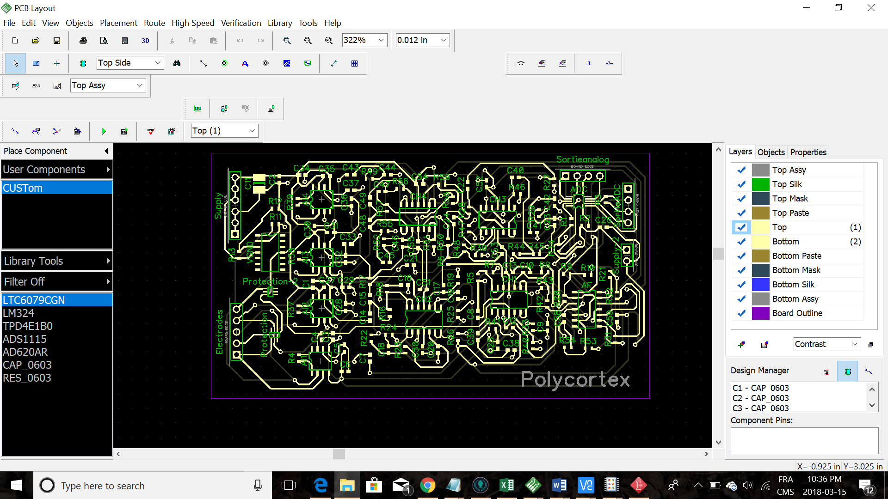

Reference

Electrode 4

Electrode 3

Electrode 2

Electrode 1

Vcc (5V)

Vcc (5V)

Vcc (5V)

GND

GND

GND

SDA

SCL

E4

E3

E2

E1

1. Install the “code” folder on a Raspberry Pi. Import all the required libraries.
2. Test the circuit by connecting a sinusoidal signal with a waveform generator at the minimal tension (i.e. 20 mV) at a frequency of 20 Hz. Connect the positive entry of the waveform generator to the electrode 1 (on the “Electrodes” header) and the negative entry to the reference electrode (on the “Electrodes header). Connect with female-female wires the GND and the Vcc (on the “Supply” header) to the related pins on the Raspberry Pi. Connect the negative entry of an oscilloscope to the GND and the positive entry to the “E1” electrode (on the “Sortieanalog” header). A square signal at 20 Hz should appear. Because the lowest amplitude generated by the instrument is much higher than an EEG signal (20 mV >> 100 µV), the output signal is saturated which explains the square form.
3. Visualise the temporal and spectral signal on the interface by connecting the SDA and SCL pins (on the “SortieADC” header) to the corresponding pins on the Raspberry Pi with female-female wires. Connect the Raspberry Pi to a screen, mouse and keyboard. Open “app.py”, available in the “code” folder (previously installed at step 7), with an IDE such as Spyder 3. Run the program. An interface should appear on the screen with the temporal and frequential signals. The square signal should appear on the top left corner diagram et a pic indicating the dominant frequency should appear at around 20 Hz on the corresponding frequency diagram.
4. Redo steps 8 and 9 with all the channels to ensure that every channel is well welded.
5. Measure the EEG by connecting electrodes to the respective pins on the “Electrodes” header according to needs. Display the 4 signals on the screen of the Raspberry Pi.